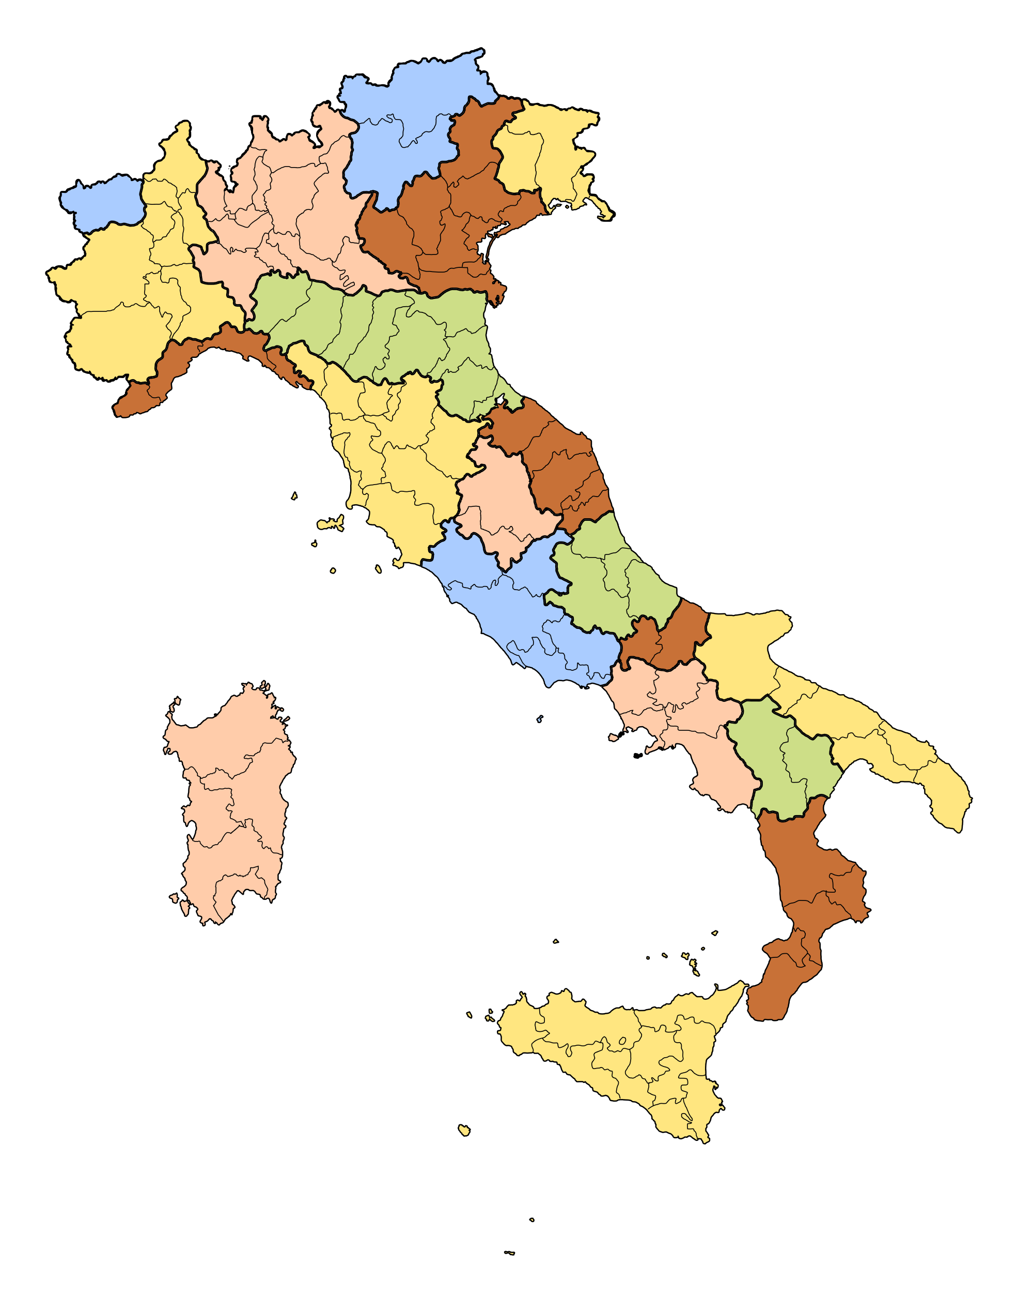
Regione Italiana ____________________________________
Città Principali: ____________________________________________________
____________________________________________________
Fiumi: ______________________________________________
____________________________________________________
Laghi:______________________________________________
Montagne: _________________________________________
___________________________________________________
CONFINI:__________________________________________
______________________________________________________________________________________________
Clima:________________________________________________________________________________________
______________________________________________________________________________________________
______________________________________________________________________________________________
Abitanti: _____________________________________________________________________________________
Settori Economici:
PRIMARIO:
_____________________________________________________________________________________________
_____________________________________________________________________________________________
_____________________________________________________________________________________________
_____________________________________________________________________________________________
SECONDARIO:
____________________________________________________________________________________________
____________________________________________________________________________________________
____________________________________________________________________________________________
____________________________________________________________________________________________
TERZIARIO:
___________________________________________________________________________________________
___________________________________________________________________________________________
___________________________________________________________________________________________
___________________________________________________________________________________________
___________________________________________________________________________________________

